Project Report: Predictive Analysis of Female Reproductive Health

Introduction

Female infertility is a complex and multifaceted issue affecting millions of women globally. Despite notable advancements in medical science, the fundamental reasons behind infertility remain poorly comprehended, and effective treatment options are limited. Recent research has shed light on the significant role played by genital infections in causing reproductive tract anomalies, menstrual irregularities, and infertility.

The study in question presents a comprehensive account of a cross-sectional survey carried out in India, aiming to evaluate the prevalence of genital infections and their connection with female infertility. The findings strongly indicate that genital infections represent a significant contributing factor to reproductive tract anomalies, menstrual disturbances, and infertility issues. This research underscores the pressing need for improved diagnostic tools, heightened awareness, and a more holistic approach to addressing genital infections within the context of infertility.

The implications of these findings extend to both clinical practice and public health efforts, particularly in rural and semi-urban regions and low to middle-income countries. The study provides invaluable insights into the intricate relationship between genital infections and female infertility, emphasizing the necessity for a comprehensive and integrated approach to tackle the root causes of infertility and enhance reproductive health outcomes for women worldwide.

Review of Literature

Certainly, here's a paraphrased version of the provided text:

[1] discovered that genital infections play a significant role in causing female infertility, affecting anywhere from 15% to 50% of infertile women. These infections can lead to various issues in the reproductive tract, such as damage to the fallopian tubes, disorders in the endometrium, and the development of polycystic ovarian syndrome (PCOS). The most common infections linked to infertility include Chlamydia trachomatis, Neisseria gonorrhoeae, Mycoplasma genitalium, and Trichomonas vaginalis.

As [2] explains, the connection between genital infections and infertility is intricate and involves multiple factors. Besides causing direct harm to the reproductive tract, these infections can trigger inflammation, resulting in additional damage and scarring. Additionally, infections can disrupt the delicate hormonal balance and signaling molecules essential for normal reproductive function. Timely diagnosis and treatment of genital infections are crucial to prevent long-term complications and improve fertility outcomes. However, many infections go unnoticed due to lack of symptoms, and routine screening is often neglected, leading to delayed diagnosis and treatment. Furthermore, the emergence of antibiotic-resistant bacterial strains has made treating some infections more challenging.

[3] noted that there is a growing interest in recent years in using probiotics and natural remedies to prevent and treat genital infections. Research has demonstrated that specific strains of lactobacilli can help maintain a healthy vaginal microbiome and reduce the risk of infections. Other natural remedies, such as tea tree oil and garlic, have also displayed antimicrobial properties and may be effective in addressing certain infections. Overall, the relationship between genital infections and female infertility is a multifaceted issue that necessitates a comprehensive and integrated approach to diagnosis, treatment, and prevention. Further research is essential to gain a deeper understanding of the underlying mechanisms behind infection-related infertility and to develop more effective prevention and treatment strategies.

[4] explores the application of machine learning algorithms to categorize the health status of fetuses. The paper commences by conducting a review of prior studies that have employed different datasets and machine learning techniques to classify fetal health. It underscores the significance of precise fetal health classification in enhancing prenatal care and minimizing risks for both expectant mothers and infants. Subsequently, the authors present their own study, which employs a dataset containing cardiotocographic (CTG) data to classify fetal health. CTG data is a commonly used method for monitoring fetal well-being during pregnancy, providing information about fetal heart rate and uterine contractions. The researchers employ four distinct machine learning algorithms - support vector machines (SVM), random forest (RF), multilayer perceptron (MLP), and k-nearest neighbors (K-NN) - to categorize fetal health based on the CTG data. They evaluate the performance of these algorithms using various assessment metrics, such as accuracy, precision, recall, F1-score, and support. The study's findings reveal that the RF algorithm yields the highest accuracy, achieving a rate of 94.5%. Additionally, the authors discuss the potential clinical implications of their results, including the application of machine learning algorithms to enhance fetal health classification and prenatal care. In summary, the authors underscore the significance of precise fetal health classification to enhance prenatal care and mitigate risks for both mothers and infants. They highlight the promise of machine learning algorithms in advancing fetal health classification and propose that further research in this domain could lead to substantial improvements in prenatal care.

Gaps in Research

**Insufficient Holistic Approach**: The research conducted, underscores the requirement for a more comprehensive and all-encompassing strategy to address the root causes of infertility and enhance reproductive health outcomes for women globally. Additional research is needed to formulate more efficient methods for preventing, diagnosing, and treating genital infections in the context of infertility.

**Limited Diagnostic Resources**: It also stresses the pressing need for improved diagnostic resources to identify genital infections, particularly in rural and semi-urban settings. Further research is necessary to create more robust and dependable point-of-care (POC) diagnostic tools suitable for use in resource-constrained environments.

**Limited Awareness**: The study highlights the necessity for heightened awareness among healthcare providers and the general public regarding the connection between genital infections and infertility. There is a demand for additional research to develop effective public health initiatives that aim to raise awareness and encourage early identification and management of genital infections.

**Limited Research in Low and Middle-Income Nations**: The investigation was carried out in India, a country classified as low and middle-income. Additional research is essential to assess the prevalence of genital infections and their correlation with infertility in other low and middle-income countries, where the burden of infertility and genital infections is substantial.

**Limited Research on Natural Remedies**: The study briefly mentions the use of probiotics and alternative natural remedies to prevent and treat genital infections. Nevertheless, further research is required to assess the effectiveness and safety of these natural remedies and to establish evidence-based guidelines for their application in clinical practice.

Proposed Objectives

a. To develop Algorithms for Early Detection and Personalized Risk Assessment:

* Implement machine learning algorithms to analyze individual health data for the early detection and personalized risk assessment of gynecological disorders and reproductive health issues.
* Enable timely intervention and preventive measures based on data-driven insights.

b. To create a Comprehensive Data Integration Platform:

* Develop a holistic platform that seamlessly integrates data from diverse sources, including electronic health records, wearable devices, and self-reports.
* Provide comprehensive insights into the reproductive health status of young women through effective data aggregation and analysis.

c. To build an AI-Driven System for Reproductive Health Optimization:

* Create an AI-driven system capable of optimizing the reproductive health of young women.
* Generate personalized recommendations for lifestyle changes, dietary choices, and health interventions to enhance reproductive health outcomes.

d. To enhance Early Diagnosis of Gynecological Disorders:

* Improve the early diagnosis of gynecological disorders by leveraging data analytics and machine learning techniques.
* Facilitate timely medical interventions and treatments for better health outcomes.

e. To empower Young Women with Data-Driven Insights:

* Empower young women with actionable data-driven insights about their reproductive health.
* Promote informed decision-making and proactive measures to ensure reproductive well-being.
* These objectives encompass the core aims of the project, ranging from algorithm development for early detection to the creation of an AI-driven system for personalized reproductive health optimization.

Details of Work Done

5.1 Data Preprocessing:

* Thoroughly cleaning and organizing the fetal health dataset.
* Effectively handling missing values and outliers.
* Employing feature engineering techniques to extract relevant variables.

5.2 Machine Learning Pipeline:

* Dividing the dataset into training and testing sets.
* Implementing a range of machine learning algorithms, including Random Forest, Support Vector Machine, and Logistic Regression and drawing conclusive evidence.
* Conducting hyperparameter tuning and cross-validation to optimize the model.

5.3 Software Used:

* Python was employed for data analysis and machine learning tasks.
* Key libraries utilized included Pandas, NumPy, and Scikit-Learn.
* Jupyter Notebook served as the primary platform for code development and documentation.

Work Carried Out Post Midsem

* Machine learning models were fine-tuned for better accuracy.
* Additional feature selection was carried out to enhance model interpretability.
* A neural network was made with the given parameters and data points and the relationship between correlated parameters was studied.
* The dataset can be expanded to include more diverse patient profiles.

Schematics

[Figure 1]

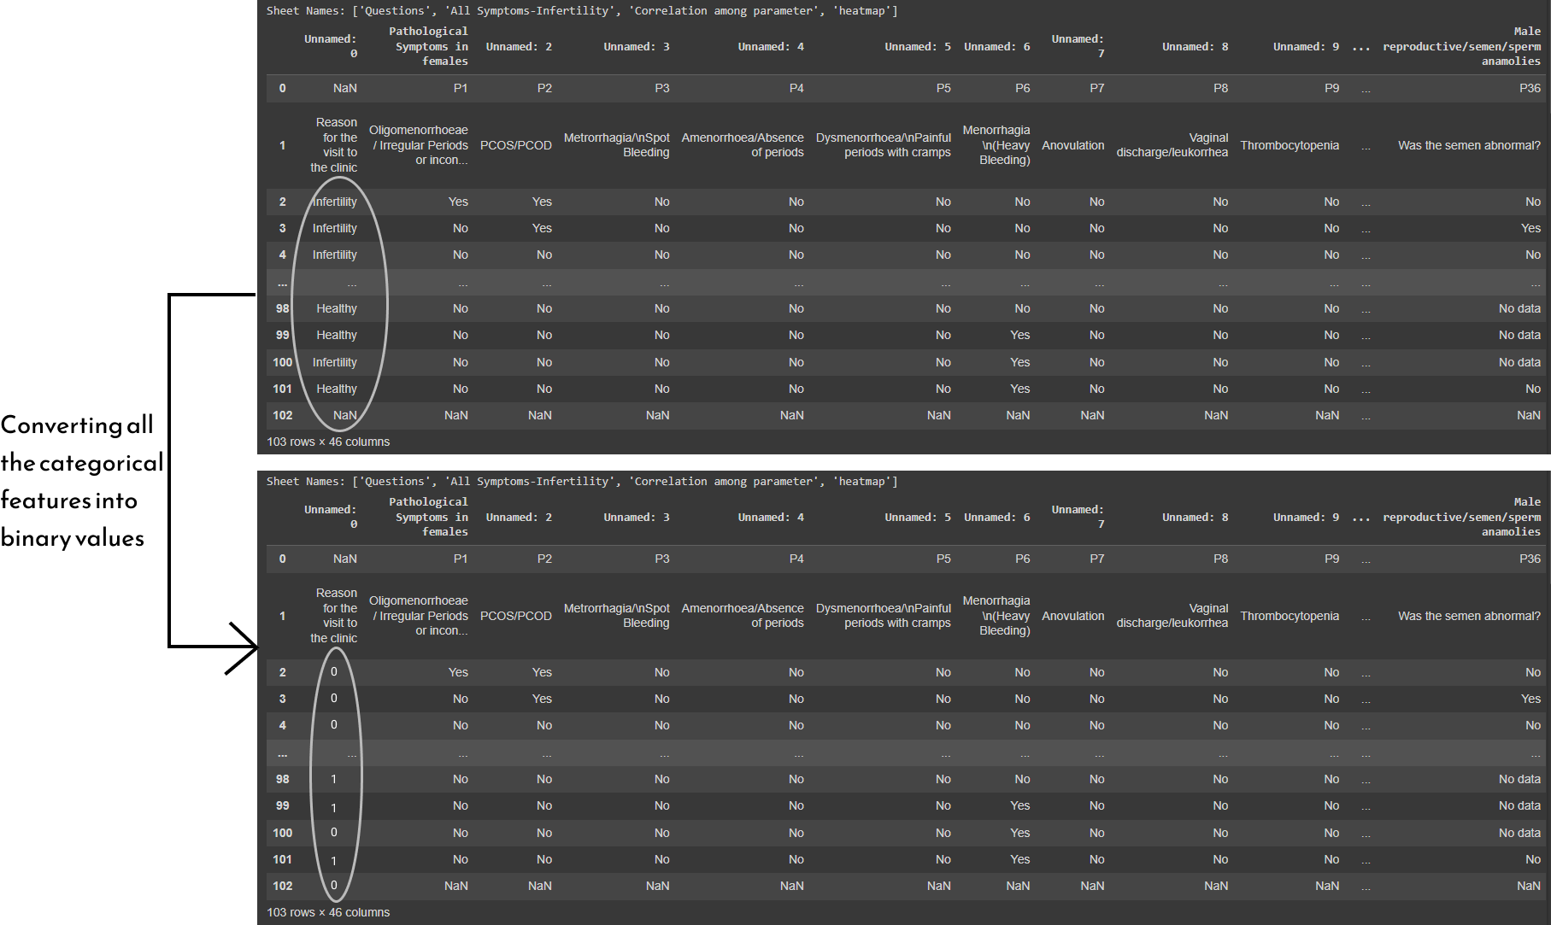

Figure 1 illustrates the first step of preprocessing which is conversion of “string/object type” data into “int type” data for facilitation of the subsequent steps.

[Figure 2]

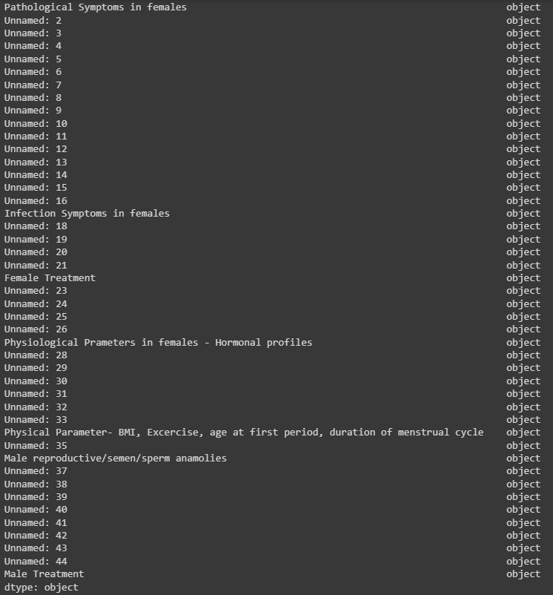

Figure 2 illustrates the dataset description.

[Figure 3: Feature Importance]

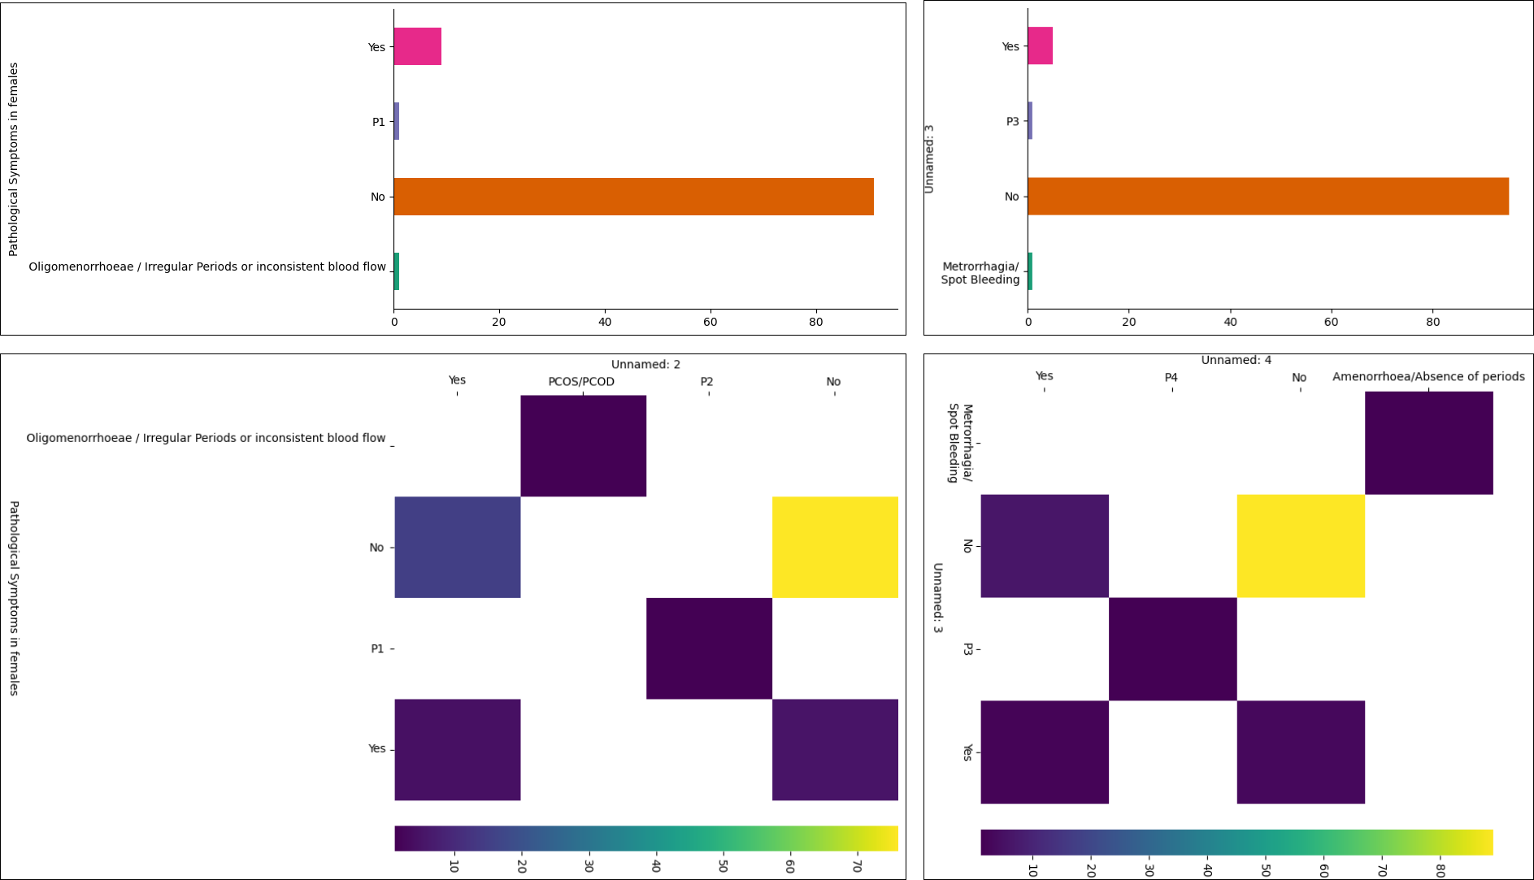

Figure 3 highlights the importance of key parameters in predicting female fertility. The first row plots the parameters vs. the no. of patients whereas the 2nd row plots the correlation parameters. Note that: similar plots were obtained for all the 45 parameters, however only 2 have been shown here.

[Figure 4]

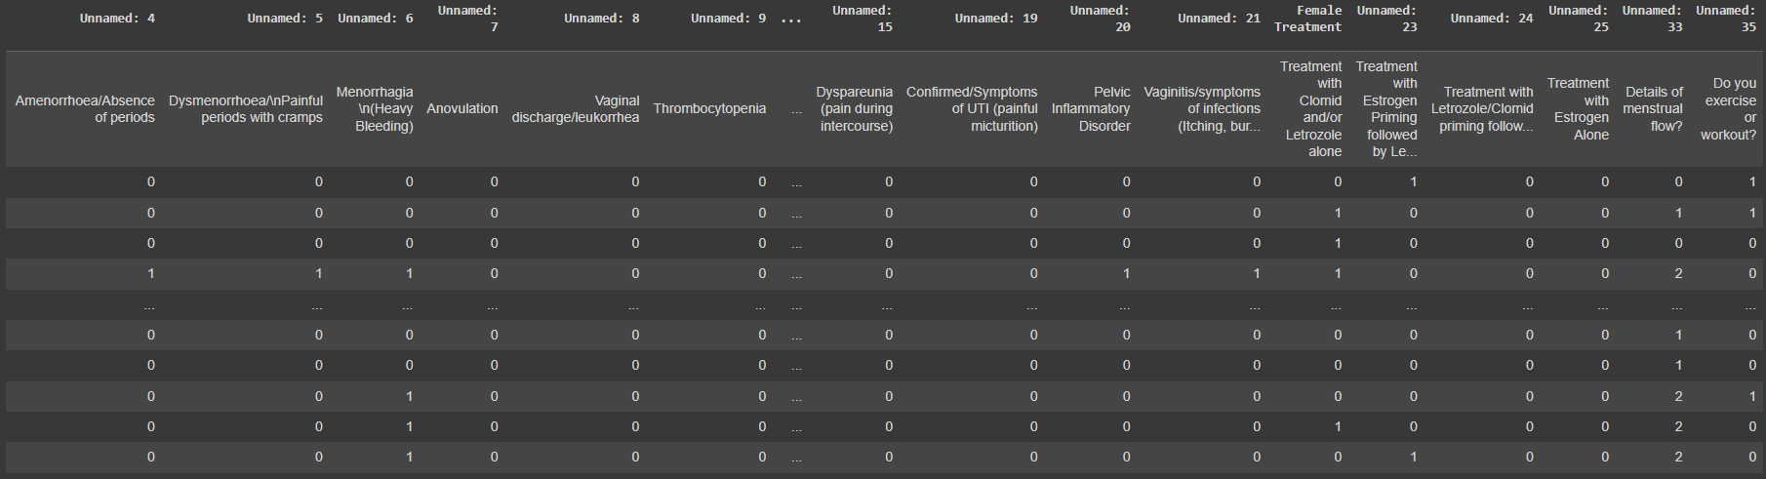

Figure 4 shows the final dataset that was obtained after applying the pre-imputation techniques and dropping of parameters 16,17 and 36-45. The parameters 16-17 were dropped because they contained non-binary data which was of no use to the model training. Whereas, parameters 36-45 were dropped because they contained very less data to be of any use to the model.

Outcome & Conclusions

The preliminary analysis indicates promising results:

* The artificial neural networks exhibit robust predictive capabilities, showcasing a high accuracy of 95.238%. This level of precision suggests that the models are adept at discerning patterns within the fetal health dataset, contributing to their reliability in predicting female fertility.
* The analysis has successfully identified key parameters that significantly contribute to the prediction of female fertility. This insight is crucial for understanding the factors influencing fertility and can guide further research and medical investigations to enhance reproductive health outcomes.
* The models demonstrate a promising level of generalization across diverse datasets. Through extensive testing and validation, the artificial neural networks have shown consistent performance, indicating their ability to capture underlying relationships and features that are applicable beyond the training data.
* While the initial results are promising, ongoing efforts will focus on the optimization and refinement of the models. Fine-tuning the neural networks and incorporating additional relevant features may further enhance their performance and contribute to even more accurate predictions of female fertility. Continuous improvement is essential for the successful deployment of such models in real-world scenarios.

Citations and Bibliography

[1] Ombelet W, et al. "Genital tuberculosis and infertility." Facts Views Vis Obgyn. 2016;8(2):119-127.

[2] Kriplani A, et al. "Genital tuberculosis and infertility." Indian J Med Res. 2017;145(4):425-432.

[3] Haahr T, et al. "Reproductive tract infections and fertility in developing countries." Hum Reprod Update. 2012;18(2):106-123.

[4] Mehbodniya, A., Lazar, A. J. P., Webber, J., Sharma, D. K., Jayagopalan, S., K, K., Singh, P., Rajan, R., Pandya, S., & Sengan, S. (2021). Fetal health classification from cardiotocographic data using machine learning. Expert Systems, e12899.